Week-4 (DAY-21) Hands-On. Keerthivasan R
Please download and refer shared Code template (LinqCodeTemplate) and solve problems as given below.
(Please Refer Problem-1 Solved in the Code Template and solve rest of other problems in the same project accordingly)
Problem Level- 1 and 2:
1.Write a LINQ query to search and display all products with category “FMCG”.
CODE:
using System;
using System.Collections.Generic;
using System.Linq;
using System.Text;
using System.Threading.Tasks;

namespace HandsOnDay21
{
public class Product1
{
public int ProCode { get; set; }
public string ProName { get; set; }
public string ProCategory { get; set; }
public double ProMrp { get; set; }

public List<Product1> GetProducts()
{
return new List<Product1>
{
new Product1{ ProCode=101, ProName="Soap", ProCategory="FMCG", ProMrp=25 },
new Product1{ ProCode=102, ProName="Shampoo", ProCategory="FMCG", ProMrp=45 },
new Product1{ ProCode=103, ProName="Rice", ProCategory="Grain", ProMrp=60 },
new Product1{ ProCode=104, ProName="Wheat", ProCategory="Grain", ProMrp=40 },
new Product1{ ProCode=105, ProName="Oil", ProCategory="FMCG", ProMrp=120 }
};
}
}
internal class LINQ_Query_Problem_01
{
static void Main(string[] args) {

Product1 product = new Product1();

var products = product.GetProducts();

var result = products.Where(p => p.ProCategory == "FMCG").ToList();

foreach (var item in result) {

Console.WriteLine($"{item.ProCode}\t{item.ProName}\t{item.ProMrp}");
}
Console.ReadLine();
}
}
}
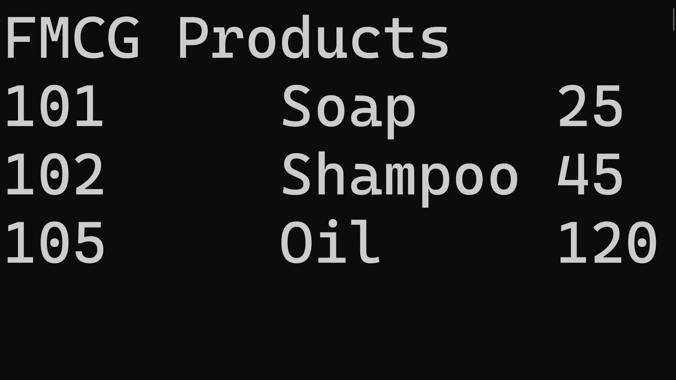
OUTPUT:
2. Write a LINQ query to search and display all products with category “Grain”.
CODE:
using System;
using System.Collections.Generic;
using System.Linq;
using System.Text;
using System.Threading.Tasks;

namespace HandsOnDay21
{
public class Product2
{
public int ProCode { get; set; }
public string ProName { get; set; }
public string ProCategory { get; set; }
public double ProMrp { get; set; }

public List<Product2> GetProducts()
{
return new List<Product2>
{
new Product2{ ProCode=101, ProName="Soap", ProCategory="FMCG", ProMrp=25 },
new Product2{ ProCode=102, ProName="Shampoo", ProCategory="FMCG", ProMrp=45 },
new Product2{ ProCode=103, ProName="Rice", ProCategory="Grain", ProMrp=60 },
new Product2{ ProCode=104, ProName="Wheat", ProCategory="Grain", ProMrp=40 },
new Product2{ ProCode=105, ProName="Oil", ProCategory="FMCG", ProMrp=120 }
};
}
}
internal class LINQ_Query_Problem_02
{
static void Main(string[] args) {

Product2 product2 = new Product2();

//products with category GRAIN
var products = product2.GetProducts();

var result = products.Where(p=> p.ProCategory=="Grain").ToList();

foreach (var item in result) {
Console.WriteLine($"{item.ProCode}\t{item.ProName}\t{item.ProMrp}");
}

Console.ReadLine();

}
}
}
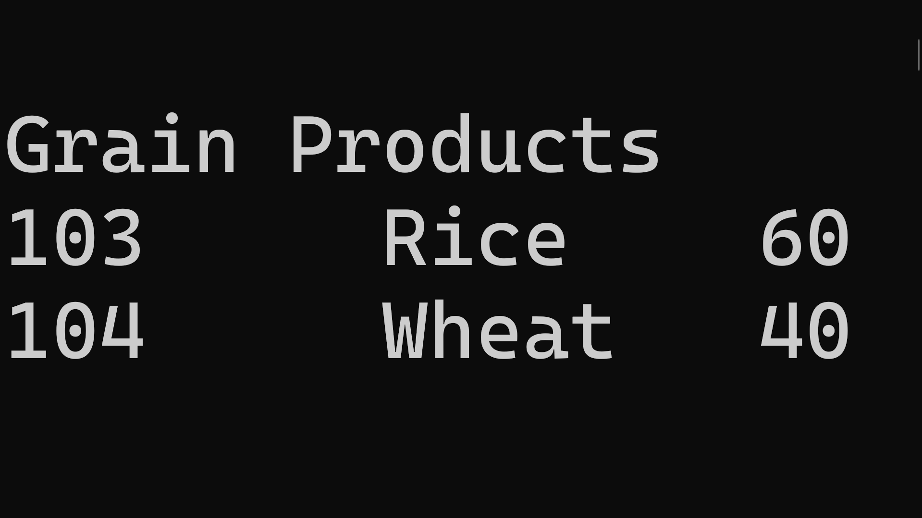
OUTPUT:
3. Write a LINQ query to sort products in ascending order by product code.
CODE:
using System;
using System.Collections.Generic;
using System.Linq;
using System.Text;
using System.Threading.Tasks;

namespace HandsOnDay21
{
public class Product3
{
public int ProCode { get; set; }
public string ProName { get; set; }
public string ProCategory { get; set; }
public double ProMrp { get; set; }

public List<Product3> GetProducts()
{
return new List<Product3>
{
new Product3{ ProCode=101, ProName="Soap", ProCategory="FMCG", ProMrp=25 },
new Product3{ ProCode=102, ProName="Shampoo", ProCategory="FMCG", ProMrp=45 },
new Product3{ ProCode=103, ProName="Rice", ProCategory="Grain", ProMrp=60 },
new Product3{ ProCode=104, ProName="Wheat", ProCategory="Grain", ProMrp=40 },
new Product3{ ProCode=105, ProName="Oil", ProCategory="FMCG", ProMrp=120 }
};
}
}
internal class LINQ_Query_Problem_03
{
static void Main(string[] args) {

Product3 product = new Product3();

// 1. Get the list from the method
var productList = product.GetProducts();

// 2. Sort the list, not the single 'product' object
var result3 = productList.OrderBy(p => p.ProCode);

Console.WriteLine("\nSorted by Product Code:");
foreach (var item in result3)
Console.WriteLine($"{item.ProCode}\t{item.ProName}");
}
}
}
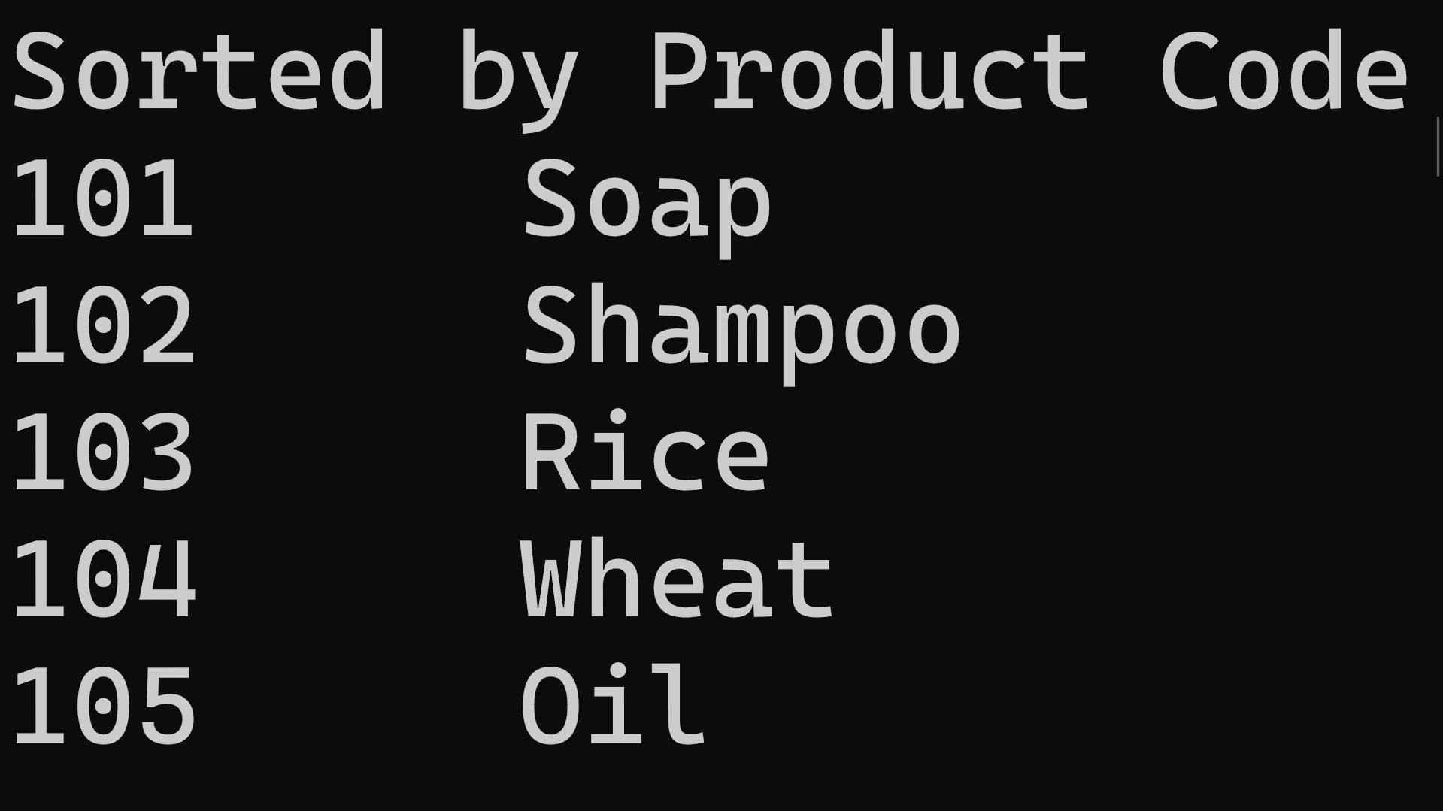
OUTPUT:

4. Write a LINQ query to sort products in ascending order by product Category.
CODE:
using System;
using System.Collections.Generic;
using System.Linq;
using System.Text;
using System.Threading.Tasks;
namespace HandsOnDay21
{
public class Product4
{
public int ProCode { get; set; }
public string ProName { get; set; }
public string ProCategory { get; set; }
public double ProMrp { get; set; }
public List<Product4> GetProducts()
{
return new List<Product4>
{
new Product4{ ProCode=101, ProName="Soap", ProCategory="FMCG", ProMrp=25 },
new Product4{ ProCode=102, ProName="Shampoo", ProCategory="FMCG", ProMrp=45 },
new Product4{ ProCode=103, ProName="Rice", ProCategory="Grain", ProMrp=60 },
new Product4{ ProCode=104, ProName="Wheat", ProCategory="Grain", ProMrp=40 },
new Product4{ ProCode=105, ProName="Oil", ProCategory="FMCG", ProMrp=120 }
};
}
}
internal class LINQ_Query_Problem_04
{
static void Main(string[] args) {
Product4 product = new Product4();
//sort products in ascending order by product Category
var products = product.GetProducts();
var result = products.OrderBy(p => p.ProCategory);
foreach (var item in result) {
Console.WriteLine($"{item.ProCategory}\t{item.ProName}");
}
Console.ReadLine();
}
}
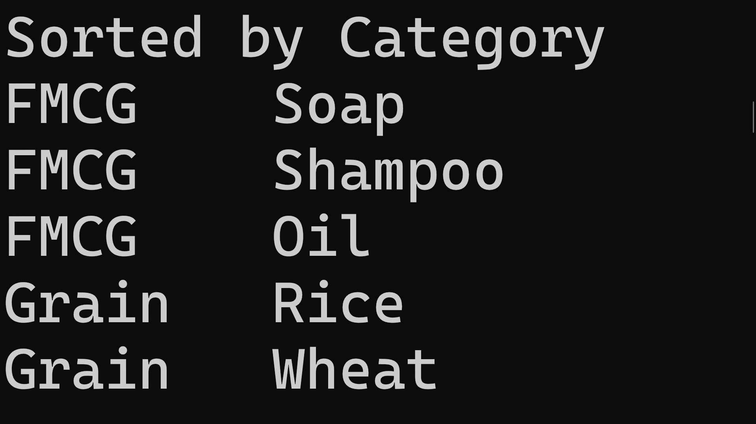
}
OUTPUT:

5. Write a LINQ query to sort products in ascending order by product Mrp.
CODE:
using System;
using System.Collections.Generic;
using System.Linq;
using System.Text;
using System.Threading.Tasks;
namespace HandsOnDay21
{
public class Product5
{
public int ProCode { get; set; }
public string ProName { get; set; }
public string ProCategory { get; set; }
public double ProMrp { get; set; }
public List<Product5> GetProducts()
{
return new List<Product5>
{
new Product5{ ProCode=101, ProName="Soap", ProCategory="FMCG", ProMrp=25 },
new Product5{ ProCode=102, ProName="Shampoo", ProCategory="FMCG", ProMrp=45 },
new Product5{ ProCode=103, ProName="Rice", ProCategory="Grain", ProMrp=60 },
new Product5{ ProCode=104, ProName="Wheat", ProCategory="Grain", ProMrp=40 },
new Product5{ ProCode=105, ProName="Oil", ProCategory="FMCG", ProMrp=120 }
};
}
}
internal class LINQ_Query_Problem_05
{
static void Main(string[] args) {
Product5 product = new Product5();
//sort products in ascending order by product Mrp
var products = product.GetProducts();
var result = products.OrderBy(p=> p.ProMrp).ToList();
foreach (var item in result)
{
Console.WriteLine($"{item.ProMrp}\t{item.ProName}");
}
Console.ReadLine();
}
}
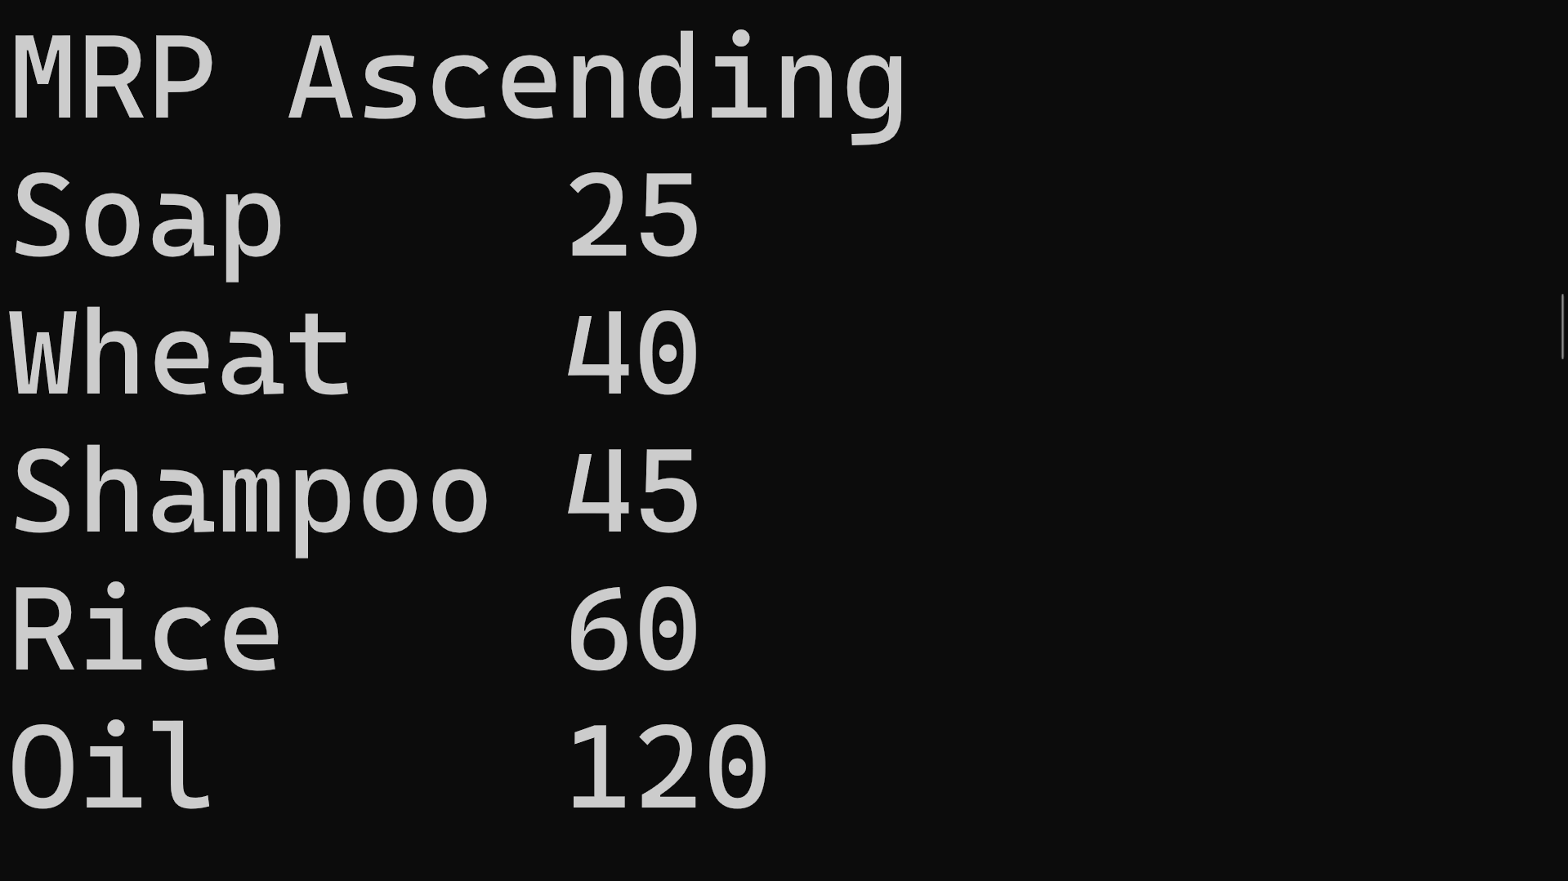
}
OUTPUT:
6. Write a LINQ query to sort products in descending order by product Mrp.
CODE:
using System;
using System.Collections.Generic;
using System.Linq;
using System.Text;
using System.Threading.Tasks;
namespace HandsOnDay21
{
public class Product6
{
public int ProCode { get; set; }
public string ProName { get; set; }
public string ProCategory { get; set; }
public double ProMrp { get; set; }
public List<Product6> GetProducts()
{
return new List<Product6>
{
new Product6{ ProCode=101, ProName="Soap", ProCategory="FMCG", ProMrp=25 },
new Product6{ ProCode=102, ProName="Shampoo", ProCategory="FMCG", ProMrp=45 },
new Product6{ ProCode=103, ProName="Rice", ProCategory="Grain", ProMrp=60 },
new Product6{ ProCode=104, ProName="Wheat", ProCategory="Grain", ProMrp=40 },
new Product6{ ProCode=105, ProName="Oil", ProCategory="FMCG", ProMrp=120 }
};
}
}
internal class LINQ_Query_Problem_06
{
static void Main(string[] args) {
Product6 product6 = new Product6();
//sort products in descending order by product Mrp
var products = product6.GetProducts();
var result = products.OrderByDescending(p=> p.ProMrp).ToList();
foreach (var item in products)
{
Console.WriteLine($"{item.ProName}\t{item.ProMrp}");
}
Console.ReadLine();
}
}
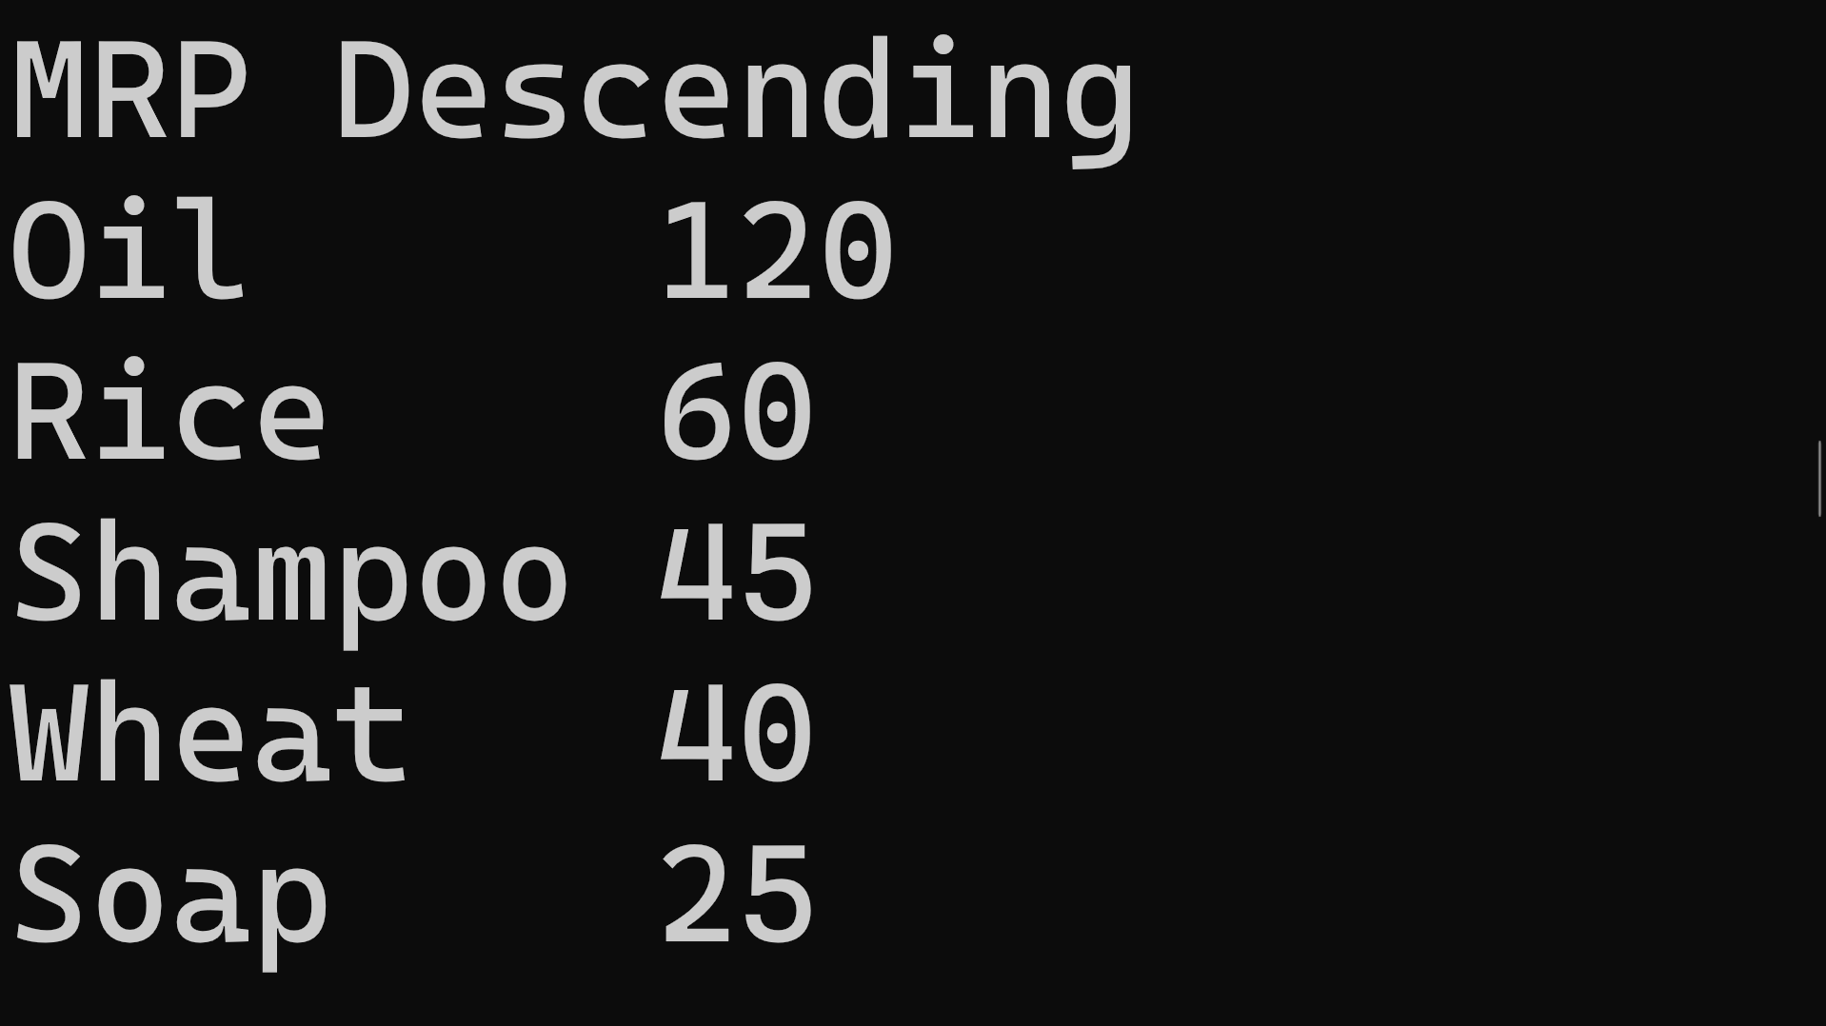
}
OUTPUT:
7. Write a LINQ query to display products group by product Category.
CODE:using System;
using System.Collections.Generic;
using System.Linq;
using System.Text;
using System.Threading.Tasks;
namespace HandsOnDay21
{
public class Product7
{
public int ProCode { get; set; }
public string ProName { get; set; }
public string ProCategory { get; set; }
public double ProMrp { get; set; }

public List<Product7> GetProducts()
{
return new List<Product7>
{
new Product7{ ProCode=101, ProName="Soap", ProCategory="FMCG", ProMrp=25 },
new Product7{ ProCode=102, ProName="Shampoo", ProCategory="FMCG", ProMrp=45 },
new Product7{ ProCode=103, ProName="Rice", ProCategory="Grain", ProMrp=60 },
new Product7{ ProCode=104, ProName="Wheat", ProCategory="Grain", ProMrp=40 },
new Product7{ ProCode=105, ProName="Oil", ProCategory="FMCG", ProMrp=120 }
};
}
}
internal class LINQ_Query_Problem_07
{
static void Main(string[] args)
{
Product7 product7 = new Product7();
var products = product7.GetProducts();
// Perform the grouping
var result = products.GroupBy(p => p.ProCategory).ToList();
// Iterate over 'result', NOT 'products'
foreach (var group in result)
{
// group.Key is the Category Name (e.g., "FMCG" or "Grain")
Console.WriteLine($"\nCategory: {group.Key}");
// Each 'group' acts like a list of products within that category
foreach (var item in group)
{
Console.WriteLine($" - {item.ProName}: {item.ProMrp}");
}
}
Console.ReadLine();
}
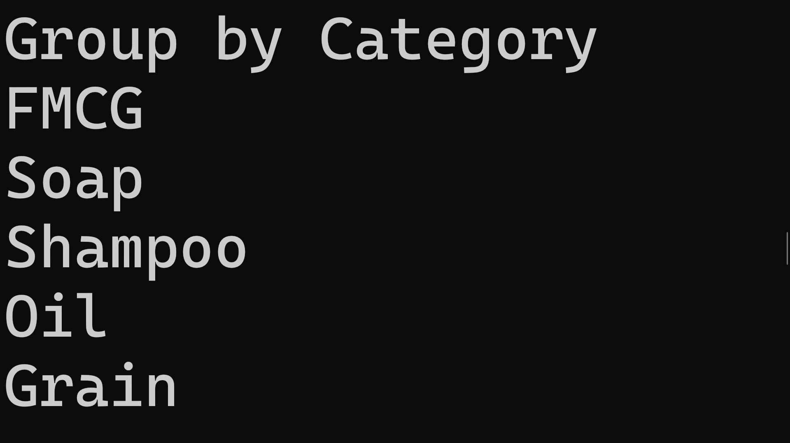
}
}
OUTPUT:

8. Write a LINQ query to display products group by product Mrp.
CODE:
using System;
using System.Collections.Generic;
using System.Linq;
using System.Text;
using System.Threading.Tasks;
namespace HandsOnDay21
{
public class Product8 {
public int ProCode { get; set; }
public string ProName { get; set; }
public string ProCategory { get; set; }
public double ProMrp { get; set; }

public List<Product8> GetProducts() {
return new List<Product8> {
new Product8{ ProCode=101, ProName="Soap", ProCategory="FMCG", ProMrp=25 },
new Product8{ ProCode=102, ProName="Shampoo", ProCategory="FMCG", ProMrp=45 },
new Product8{ ProCode=103, ProName="Rice", ProCategory="Grain", ProMrp=60 },
new Product8{ ProCode=104, ProName="Wheat", ProCategory="Grain", ProMrp=40 },
new Product8{ ProCode=105, ProName="Oil", ProCategory="FMCG", ProMrp=120 }
};
}
}
internal class LINQ_Query_Problem_08
{
static void Main(string[] args) {
Product8 product = new Product8();
var products = product.GetProducts();
// 1. Group the products by Mrp
var result = products.GroupBy(p => p.ProMrp).ToList();
Console.WriteLine("\nGroup by MRP:");
// 2. Loop through 'result' (the groups), NOT 'products' (the raw list)
foreach (var group in result) {
// group.Key is the actual MRP value (e.g., 25, 45, 60...)
Console.WriteLine("\nMRP: " + group.Key);
// Loop through all products that have this specific MRP
foreach (var item in group)
{
Console.WriteLine($" - {item.ProName}");
}
}
}
}

}
OUTPUT:

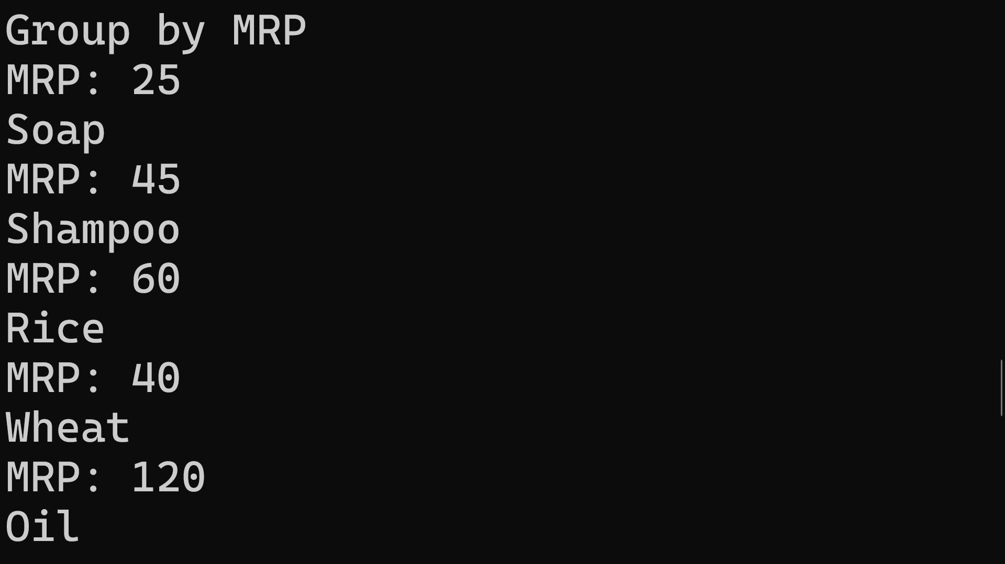
9. Write a LINQ query to display product detail with highest price in FMCG category.
CODE:
using System;
using System.Collections.Generic;
using System.Linq;
using System.Text;
using System.Threading.Tasks;
namespace HandsOnDay21
public class Product9 {
public int ProCode { get; set; }
public string ProName { get; set; }
public string ProCategory { get; set; }
public double ProMrp { get; set; }

public List<Product9> GetProducts() {
return new List<Product9>
{
new Product9{ ProCode=101, ProName="Soap", ProCategory="FMCG", ProMrp=25 },
new Product9{ ProCode=102, ProName="Shampoo", ProCategory="FMCG", ProMrp=45 },
new Product9{ ProCode=103, ProName="Rice", ProCategory="Grain", ProMrp=60 },
new Product9{ ProCode=104, ProName="Wheat", ProCategory="Grain", ProMrp=40 },
new Product9{ ProCode=105, ProName="Oil", ProCategory="FMCG", ProMrp=120 }
}; } }
internal class LINQ_Query_Problem_09 {
static void Main(string[] args) {
Product9 product9 = new Product9();
var products = product9.GetProducts();
// 1. Query 'products' (the List), not 'product9'
// 2. Remove the extra dot at the end
var result9 = products
.Where(p => p.ProCategory == "FMCG")
.OrderByDescending(p => p.ProMrp)
.FirstOrDefault();
Console.WriteLine("\nHighest FMCG Product:");
// 3. Simple null check to prevent a NullReferenceException
if (result9 != null)
{
Console.WriteLine($"{result9.ProName} {result9.ProMrp}");
}
else
{
Console.WriteLine("No FMCG products found.");
} } }

}
OUTPUT:

10. Write a LINQ query to display count of total products.
CODE:
using System;
using System.Collections.Generic;
using System.Linq;
using System.Text;
using System.Threading.Tasks;
namespace HandsOnDay21{
public class Product10 {
public int ProCode { get; set; }
public string ProName { get; set; }
public string ProCategory { get; set; }
public double ProMrp { get; set; }
public List<Product10> GetProducts() {
return new List<Product10> {
new Product10{ ProCode=101, ProName="Soap", ProCategory="FMCG", ProMrp=25 },
new Product10{ ProCode=102, ProName="Shampoo", ProCategory="FMCG", ProMrp=45 },
new Product10{ ProCode=103, ProName="Rice", ProCategory="Grain", ProMrp=60 },
new Product10{ ProCode=104, ProName="Wheat", ProCategory="Grain", ProMrp=40 },
new Product10{ ProCode=105, ProName="Oil", ProCategory="FMCG", ProMrp=120 }
}; } }
internal class LINQ_Query_Problem_10 {
static void Main(string[] args) {
Product10 product = new Product10();
var products = product.GetProducts();
var result10 = products.Count();
Console.WriteLine("\nTotal Products: " + result10);
} }}
OUTPUT:

11. Write a LINQ query to display count of total products with category FMCG.
CODE:
using System;
using System.Collections.Generic;
using System.Data;
using System.Linq;
using System.Runtime.InteropServices;
using System.Text;
using System.Threading.Tasks;

namespace HandsOnDay21
{
public class Product11
{
public int ProCode { get; set; }
public string ProName { get; set; }
public string ProCategory { get; set; }
public double ProMrp { get; set; }

public List<Product11> GetProducts()
{
return new List<Product11>
{
new Product11{ ProCode=101, ProName="Soap", ProCategory="FMCG", ProMrp=25 },
new Product11{ ProCode=102, ProName="Shampoo", ProCategory="FMCG", ProMrp=45 },
new Product11{ ProCode=103, ProName="Rice", ProCategory="Grain", ProMrp=60 },
new Product11{ ProCode=104, ProName="Wheat", ProCategory="Grain", ProMrp=40 },
new Product11{ ProCode=105, ProName="Oil", ProCategory="FMCG", ProMrp=120 }
};
}
}
internal class LINQ_Query_Problem_11
{
static void Main(string[] args) {

Product11 product = new Product11();

var products = product.GetProducts();

var result11 = products.Count(p => p.ProCategory == "FMCG");
Console.WriteLine("FMCG Product Count: " + result11);
}
}
}

OUTPUT:

12.Write a LINQ query to display Max price.
CODE:
using System;
using System.Collections.Generic;
using System.Linq;
using System.Text;
using System.Threading.Tasks;

namespace HandsOnDay21
{
public class Product12
{
public int ProCode { get; set; }
public string ProName { get; set; }
public string ProCategory { get; set; }
public double ProMrp { get; set; }

public List<Product12> GetProducts()
{
return new List<Product12>
{
new Product12{ ProCode=101, ProName="Soap", ProCategory="FMCG", ProMrp=25 },
new Product12{ ProCode=102, ProName="Shampoo", ProCategory="FMCG", ProMrp=45 },
new Product12{ ProCode=103, ProName="Rice", ProCategory="Grain", ProMrp=60 },
new Product12{ ProCode=104, ProName="Wheat", ProCategory="Grain", ProMrp=40 },
new Product12{ ProCode=105, ProName="Oil", ProCategory="FMCG", ProMrp=120 }
};
}
}
internal class LINQ_Query_Problem_12
{
static void Main(string[] args) {

Product12 product = new Product12();

var products = product.GetProducts();

var result12 = products.Max(p => p.ProMrp);
Console.WriteLine("Max Price: " + result12);
}
}
}

OUTPUT:
13.Write a LINQ query to display Min price.
CODE:
using System;
using System.Collections.Generic;
using System.Linq;
using System.Text;
using System.Threading.Tasks;

namespace HandsOnDay21
{
public class Product13
{
public int ProCode { get; set; }
public string ProName { get; set; }
public string ProCategory { get; set; }
public double ProMrp { get; set; }

public List<Product13> GetProducts()
{
return new List<Product13>
{
new Product13{ ProCode=101, ProName="Soap", ProCategory="FMCG", ProMrp=25 },
new Product13{ ProCode=102, ProName="Shampoo", ProCategory="FMCG", ProMrp=45 },
new Product13{ ProCode=103, ProName="Rice", ProCategory="Grain", ProMrp=60 },
new Product13{ ProCode=104, ProName="Wheat", ProCategory="Grain", ProMrp=40 },
new Product13{ ProCode=105, ProName="Oil", ProCategory="FMCG", ProMrp=120 }
};
}
}
internal class LINQ_Query_Problem_13
{
static void Main(string[] args) {

Product13 product = new Product13();

var products = product.GetProducts();

var result13 = products.Min(p => p.ProMrp);
Console.WriteLine("Min Price: " + result13);
}
}
}

OUTPUT:

14. Write a LINQ query to display whether all products are below Mrp Rs.30 or not.
CODE:
using System;
using System.Collections.Generic;
using System.Linq;
using System.Text;
using System.Threading.Tasks;

namespace HandsOnDay21
{
public class Product14
{
public int ProCode { get; set; }
public string ProName { get; set; }
public string ProCategory { get; set; }
public double ProMrp { get; set; }

public List<Product14> GetProducts()
{
return new List<Product14>
{
new Product14{ ProCode=101, ProName="Soap", ProCategory="FMCG", ProMrp=25 },
new Product14{ ProCode=102, ProName="Shampoo", ProCategory="FMCG", ProMrp=45 },
new Product14{ ProCode=103, ProName="Rice", ProCategory="Grain", ProMrp=60 },
new Product14{ ProCode=104, ProName="Wheat", ProCategory="Grain", ProMrp=40 },
new Product14{ ProCode=105, ProName="Oil", ProCategory="FMCG", ProMrp=120 }
};
}
}
internal class LINQ_Query_Problem_14
{
static void Main(string[] args) {

Product14 product = new Product14();

var products = product.GetProducts();

var result14 = products.All(p => p.ProMrp < 30);
Console.WriteLine("All products below 30: " + result14);
}
}
}
OUTPUT:

15. Write a LINQ query to display whether any products are below Mrp Rs.30 or not.
CODE:
using System;
using System.Collections.Generic;
using System.Linq;
using System.Text;
using System.Threading.Tasks;
namespace HandsOnDay21
{
public class Product15
{
public int ProCode { get; set; }
public string ProName { get; set; }
public string ProCategory { get; set; }
public double ProMrp { get; set; }
public List<Product15> GetProducts()
{
return new List<Product15>
{
new Product15{ ProCode=101, ProName="Soap", ProCategory="FMCG", ProMrp=25 },
new Product15{ ProCode=102, ProName="Shampoo", ProCategory="FMCG", ProMrp=45 },
new Product15{ ProCode=103, ProName="Rice", ProCategory="Grain", ProMrp=60 },
new Product15{ ProCode=104, ProName="Wheat", ProCategory="Grain", ProMrp=40 },
new Product15{ ProCode=105, ProName="Oil", ProCategory="FMCG", ProMrp=120 }
};
}
}
internal class LINQ_Query_Problem_15
{
static void Main(string[] args) {
Product15 product =new Product15();
var products = product.GetProducts();
var result15 = products.Any(p => p.ProMrp < 30);
Console.WriteLine("Any product below 30: " + result15);

}
}
}
OUTPUT:

